ACN PTT 1 Question Bank
Chapter 1
2 marks
1. List the key roles of ICANN.
Ans.
• Manages domain names, IP address allocation, and protocol identifiers.
• Ensures uniqueness and coordination of DNS across the internet.

2. State the Subnet Address.
Ans. A Subnet Address is the address that identifies a particular subnet within a network.
Example:
- IP Address: 192.168.1.25
- Subnet Mask: 255.255.255.0
- Subnet Address: 192.168.1.0

3. State the concept of fragmentation in IPv4.
Ans. Fragmentation is the process of dividing actual data into multiple fragments.
Fragmentation is performed when a large packet needs to be transmitted. However, Ethernet protocol in Data Link Layer has MTU(Maximum Transfer Unit) of 1500 bytes.
Therefore, when a packet is larger than 1500 bytes then it needs to be fragmented.

4. State the purpose of queuing in routers.
Ans. Queueing refers to the process of temporarily storing packets in memory buffers before they are transmitted over an output link. It is an essential function in routers because packets do not always arrive at the same rate as they can be forwarded. If too many packets arrive at once, they need to wait their turn before being sent, which is managed through queues.

4 marks
5. Illustrate the ARP address mapping process(working) with neat diagram.
Ans. 1. ARP Query Packet Broadcast
ARP Query Packet contains
• Senders IP Address
• Senders Physical Address
• Receivers IP Address (Whom Physical Address to be found)

2. Every host or router on the network receives and examines the ARP request
packet. However, only the device with the matching IP address recognizes the
request and replies by sending an ARP response packet.

3. ARP Response Packet Unicast
The response packet includes the IP address and physical (MAC) address of the
replying device. This packet is sent directly (unicast) to the original sender using
the physical address provided in the ARP request.

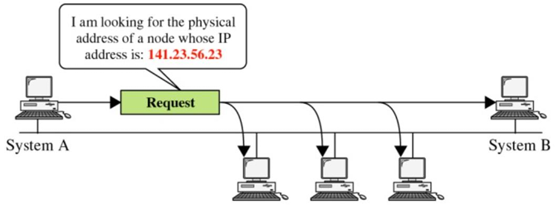
Fig : ARP working (Query Packet Broadcast)

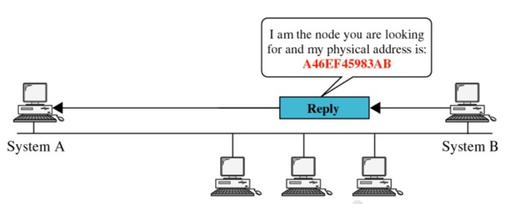
Fig : ARP working (Unicast response)

6. Explain Internet architecture with suitable diagram.
Ans. Today an Internet has a multi-backbone structure and these backbone networks run by different private corporations today.
1. Several backbone networks, operated by private communication companies, provide global internet connectivity. These backbones are interconnected through peering points, enabling data exchange between them.
2. Below the backbone level, provider networks utilize these backbone connections to offer internet services to end-users and organizations.
3. At the lowest level, customer networks access the internet through the services offered by provider networks.

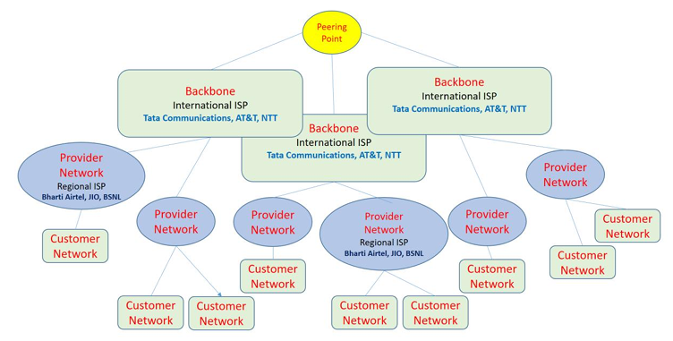

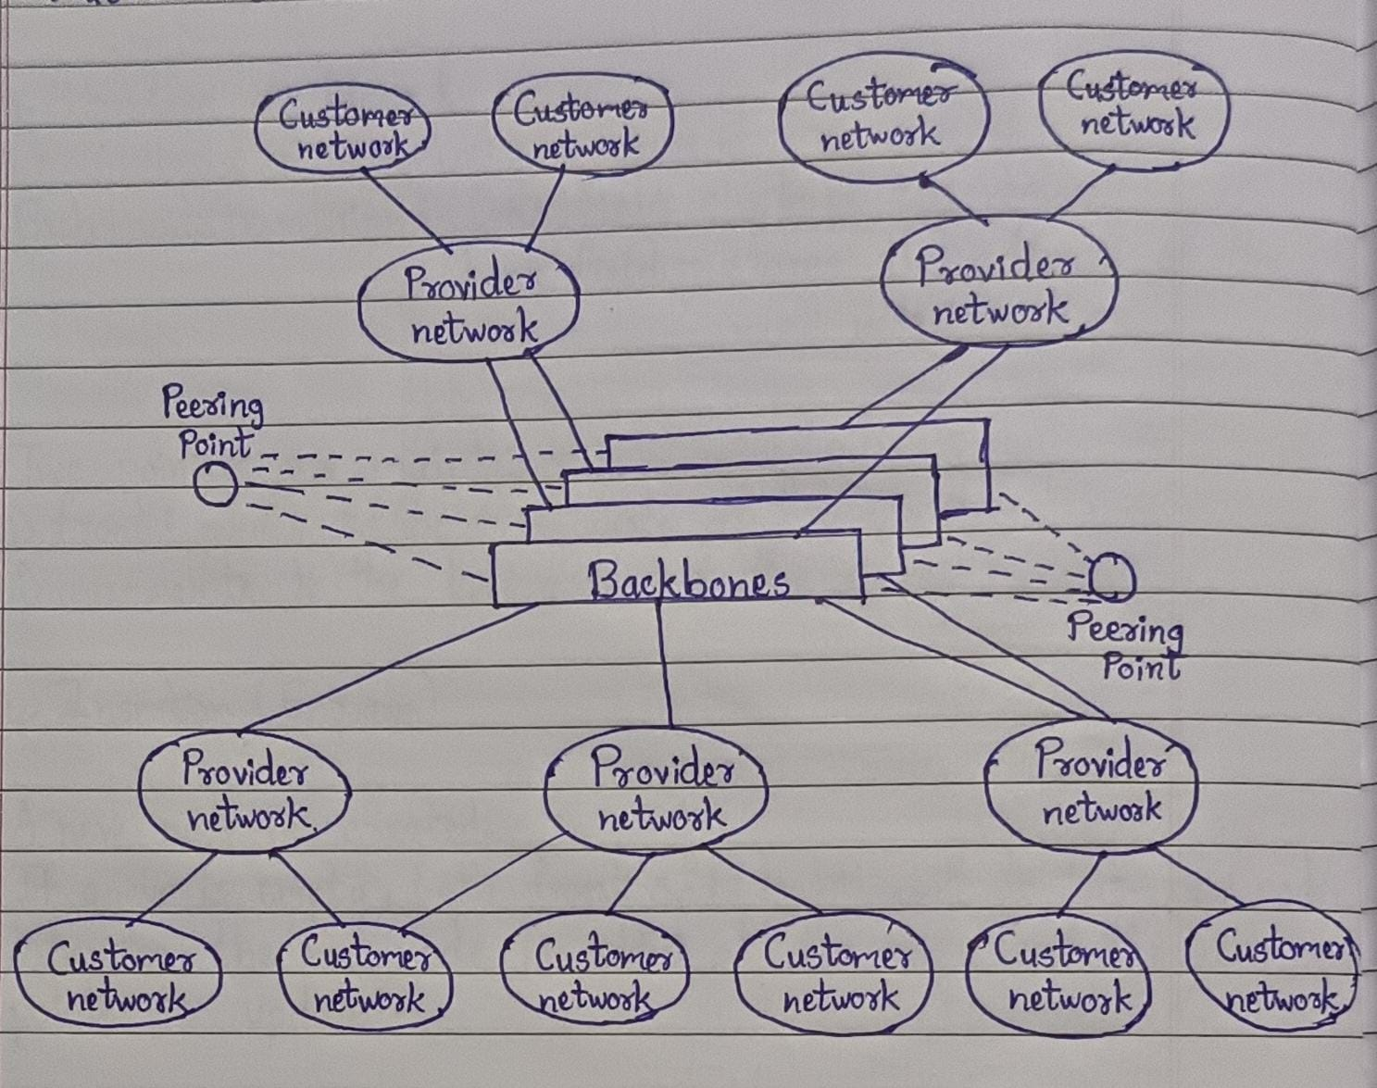
Fig : Structure of Internet
(Make any one diagram)

7. A college receives 172.16.0.0/16 and wants separate networks for different 8
departments. Design subnet for each department that can accommodate at
least 500 hosts per department.
Identify

i. Subnet Mask
ii. Network IP
iii. Usable Host IP range
iv. Broadcast address
Ans.

Address 172. 16. 0. 0/16 belongs to Class B.

-----------------------16 bits------------------|-----------------------16 bits-----------------
172 | 16 | 0 | 0
{ Net ID } { Host ID }

To represent 8 subnets we require 3 bits ( 2³ = 8), Borrow it from existing Host bits.

--------------16 bits---------|---------------16 bits----------------------
172 | 16 | 000 | 0 0000 | 0000 0000
{ Net ID } ^ { Host ID }
Borrowed for subnet ID

Subnet 1
172. 16. 0000 0000. 0000 0000 172. 16. 0. 0
172. 16. 0000 0000. 0000 0001 172. 16. 0. 1
172. 16. 0001 1111. 1111 1110 172. 16. 31. 254
172. 16. 0001 1111. 1111 1111 172. 16. 31. 255

Subnet mask : 255. 255. 224. 0
Network IP : 172. 16. 0. 0
First IP : 172. 16. 0. 1
Last IP : 172. 16. 31. 254
Broadcast IP : 172. 16. 31. 255

Subnet 2
172. 16. 0010 0000. 0000 0000 172. 16. 32. 0
172. 16. 0010 0000. 0000 0001 172. 16. 32. 1
172. 16. 0011 1111. 1111 1110 172. 16. 63. 254
172. 16. 0011 1111. 1111 1111 172. 16. 63. 255

Subnet mask : 255. 255. 224. 0
Network IP : 172. 16. 32. 0
First IP : 172. 16. 32. 1
Last IP : 172. 16. 32. 254
Broadcast IP : 172. 16. 63. 255

Subnet 3
172. 16. 0100 0000. 0000 0000 172. 16. 64. 0
172. 16. 0100 0000. 0000 0001 172. 16. 64. 1
172. 16. 0101 1111. 1111 1110 172. 16. 95. 254
172. 16. 0101 1111. 1111 1111 172. 16. 95. 255

Subnet mask : 255. 255. 224. 0
Network IP : 172. 16. 64. 0
First IP : 172. 16. 64. 1
Last IP : 172. 16. 95. 254
Broadcast IP : 172. 16. 95. 255

Subnet 4
172. 16. 0110 0000. 0000 0000 172. 16. 96. 0
172. 16. 0110 0000. 0000 0001 172. 16. 96. 1
172. 16. 0111 1111. 1111 1110 172. 16. 127. 254
172. 16. 0111 1111. 1111 1111 172. 16. 127. 255

Subnet mask : 255. 255. 224. 0
Network IP : 172. 16. 96. 0
First IP : 172. 16. 96. 1
Last IP : 172. 16. 127. 254
Broadcast IP : 172. 16. 127. 255

Subnet 5
172. 16. 1000 0000. 0000 0000 172. 16. 128. 0
172. 16. 1000 0000. 0000 0001 172. 16. 128. 1
172. 16. 1001 1111. 1111 1110 172. 16. 159. 254
172. 16. 1001 1111. 1111 1111 172. 16. 159. 255

Subnet mask : 255. 255. 224. 0
Network IP : 172. 16. 128. 0
First IP : 172. 16. 128. 1
Last IP : 172. 16. 159. 254
Broadcast IP : 172. 16. 159. 255

Subnet 6
172. 16. 1010 0000. 0000 0000 172. 16. 160. 0
172. 16. 1010 0000. 0000 0001 172. 16. 160. 1
172. 16. 1011 1111. 1111 1110 172. 16. 191. 254
172. 16. 1011 1111. 1111 1111 172. 16. 191. 255

Subnet mask : 255. 255. 224. 0
Network IP : 172. 16. 160. 0
First IP : 172. 16. 160. 1
Last IP : 172. 16. 191. 254
Broadcast IP : 172. 16. 191. 255

Subnet 7
172. 16. 1100 0000. 0000 0000 172. 16. 192. 0
172. 16. 1100 0000. 0000 0001 172. 16. 192. 1
172. 16. 1101 1111. 1111 1110 172. 16. 223. 254
172. 16. 1101 1111. 1111 1111 172. 16. 223. 255

Subnet mask : 255. 255. 224. 0
Network IP : 172. 16. 192. 0
First IP : 172. 16. 192. 1
Last IP : 172. 16. 223. 254
Broadcast IP : 172. 16. 223. 255

Subnet 8
172. 16. 1110 0000. 0000 0000 172. 16. 224. 0
172. 16. 1110 0000. 0000 0001 172. 16. 224. 1
172. 16. 1111 1111. 1111 1110 172. 16. 255. 254
172. 16. 1111 1111. 1111 1111 172. 16. 255. 255

Subnet mask : 255. 255. 224. 0
Network IP : 172. 16. 224. 0
First IP : 172. 16. 224. 1
Last IP : 172. 16. 255. 254
Broadcast IP : 172. 16. 255. 255

8. Differentiate between IPv4 and IPv6. (Any 6 points).
Ans.
Features | IPv4 | IPv6
Address Size | 32 bit | 128 bit
Header Size | Variable : 20-60 bytes | Fixed : 40 bytes
Header fields | More fields, including Header Checksum | Simplified Header;  No Header Checksum
Fragmentation | Can be done by Source and routers | Done only by the source using Fragment Extension Header
Options | Included within the main header | Handled using Extension Headers
TTL / Hop Limit | Uses TTL (Time to Live) | Uses hop limit
Protocol field | Uses protocol field | Uses next header field

9. An organization has been assigned 192.168.10.0/24 and has 4 departments
requiring 100, 50, 25, and 10 hosts. Design a suitable VLSM addressing scheme.
Ans.
100 Hosts
2⁷ = 128
Minimum 7 bits are required for hosts addressing, therefore subnet mask will be
192. 168. 10. 0/25 (total 128 Ips)

Network ID : 192. 168. 10. 0
First Valid IP : 192. 168. 10. 1
Last Valid IP : 192. 168. 10. 126
Broadcast IP : 192. 168. 10. 127

50 Hosts
2⁶ = 64
Minimum 6 bits are required for hosts addressing, therefore subnet mask will be
192. 168. 10. 0/26 (total 64 Ips)

Network ID : 192. 168. 10. 128
First Valid IP : 192. 168. 10. 129
Last Valid IP : 192. 168. 10. 190
Broadcast IP : 192. 168. 10. 191

25 Hosts
2⁵ = 32
Minimum 5 bits are required for hosts addressing, therefore subnet mask will be
192. 168. 10. 0/27 (total 32 Ips)
Network ID : 192. 168. 10. 192
First Valid IP : 192. 168. 10. 193
Last Valid IP : 192. 168. 10. 222
Broadcast IP : 192. 168. 10. 223

10 Hosts
2⁴ = 16
Minimum 4 bits are required for hosts addressing, therefore subnet mask will be
192. 168. 10. 0/28 (total 16 Ips)

Network ID : 192. 168. 10. 224
First Valid IP : 192. 168. 10. 225
Last valid IP : 192. 168. 10. 239
Broadcast IP : 192. 168. 10. 240

10. A router receives an IPv4 datagram of total size 4000 bytes.
The datagram header is 20 bytes and the outgoing network has an MTU of 1500 bytes.
i. Why does the router need to fragment the datagram? (1 Mark)
ii. Calculate the size of the data carried in each fragment. (2 Marks)
iii. Determine the number of fragments generated. (1 Mark)
iv. Explain the role of the Identification, Flags and Fragment Offset fields in
reassembling these fragments at the destination. (2 Marks)
Ans.
i. The datagram size is 4000 bytes, which is greater than the outgoing network's MTU of 1500 bytes. Therefore, the router must fragment the datagram into smaller packets.

ii. Total datagram size = 4000 bytes
Header size = 20 bytes
MTU = 1500 bytes

Original data size : 4000−20 = 3980 bytes

Maximum data per fragment : 1500−20=1480 bytes

Therefore:
- Fragment 1 data = 1480 bytes
- Fragment 2 data = 1480 bytes
- Fragment 3 data = 1020 bytes

iii. Fragment 1 = 1480
Fragment 2 = 1480
Fragment 3 = 1020
3980 = 1480 + 1480 + 1020
Therefore, 3 fragments are generated.

iv. Role of Identification, Flags and Fragment Offset :-

- Identification : All fragments of the same original datagram have the same Identification value. It helps the destination identify which fragments belong to the same datagram.

- Flags : The MF (More Fragments) flag indicates whether more fragments follow. It is 1 for the first two fragments and 0 for the last fragment.

- Fragment Offset : Indicates the position of each fragment's data within the original datagram. The destination uses it to put the fragments back in the correct order.

Thus, the destination uses Identification + Flags + Fragment Offset to correctly reassemble the original IPv4 datagram.

Chapter 2
2 marks
11.Define:
i. Inter-domain routing
ii. Intra domain routing
Ans.
i. Inter – domain routing : Routing between autonomous systems is referred to as inter domain routing.

ii. Intra – domain routing : Routing inside an autonomous system is referred to as intra-domain routing.

12. List Intra-domain unicast and multicast protocol.
Ans. (Write any 2)
Based on Distance Vector Routing : -
Unicast : RIP (Routing Information Protocol)
Multicast : DVMRP

Based on Link State Routing : -
Unicast : OSPF (Open Shortest Path First)
Multicast : MOSPF

13. What is the purpose of ICMP? List two types of ICMP messages.
Ans. ICMP (Internet Control Message Protocol) is used by network devices to send error messages and diagnostic information about IP packet delivery.

Two Types of ICMP Messages :
- Echo Request / Echo Reply – Used by the ping command to check whether a host is reachable.
- Destination Unreachable – Sent when a packet cannot reach its intended destination.

4 marks
14. Explain distance vector routing with Example.
Ans.
1. In distance vector routing, the least-cost route between any two nodes is the route with minimum distance.
2. In this algorithm, as the name implies, each node maintains a vector (table) of minimum distances to every node.
3. The table at each node also guides the packets to the desired node by showing the next stop in the route (next-hop routing).

4. Steps to build Routing Table for each node :-
i. Initialization
ii. Sharing
iii. Updating

i. Initialization
In this step, the router can send a message to its immediate neighbours i.e. those directly connected to it and find the distance between them. The distance for any entry that is not a neighbour is marked as infinite (unreachable).

ii. Sharing
In this step, each router shares its routing table with its immediate neighbours periodically and when there is a change.

iii. Updating
In this step, each router takes the received routing table from other routers and updates its own existing routing table according to the other routing tables.

Example :
Consider three routers:

A —1— B —2— C

- Router A knows that B is at a cost of 1.
- Router B knows that C is at a cost of 2.
- B shares its information with A.
- A calculates the cost to reach C : 1 + 2 = 3
Therefore, Router A updates its routing table:
Destination | Cost | Next Hop
B | 1 | B
C | 3 | B

So, A reaches C through B with a total cost of 3.

15. State the characteristics of the Routing Information Protocol (RIP).
(Any four points)
Ans. 1. RIP protocol is based on Distance vector routing algorithm.
2. RIP is an Intra-domain routing protocol.
3. Maximum Hope count limit is 15, if reached to 16 it will be considered as Unreachable.
4. RIP suitable for small networks due to limited maximum hope count.
5. RIP uses UDP service at transport layer.
6. Each router sends the routing update out of all active interfaces every 30 seconds.
7. Each router also receives routing updates from its neighbouring routers.

16. Describe the RIP message format along with purpose of each field.
Ans.
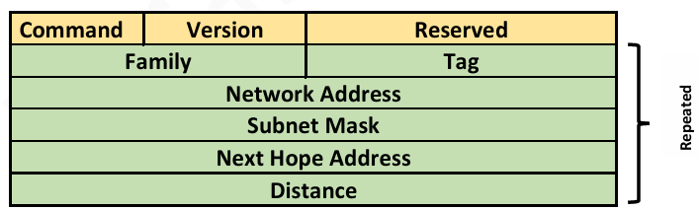
Fig : RIP Message Format

Command (8 bit) - type of message: request (1) or response (2).
Version (8 bit) - current Version 2
Family (16 bit) - Family of protocol, for TCP/IP value is 2
Tag (16 bit) - Information about autonomous system
Network Address (32 bit) - Destination address
Subnet Mask (32bit) – To identify prefix bits
Next Hope Address (32bit) – Defines via which interface packet can reach destination
Distance (32bit) - Number of hops to the destination

17. Describe Features of OSPF. (Any four)
Ans. 1. It is an interior gateway protocol that has been designed within a single autonomous system.
2. It is based on a link-state routing algorithm in which each router contains the
information of every domain, and based on this information, it determines the
shortest path.
3. Every router contains the same information about the network. The way the router
learns this information by sending LSA (Link State Advertisements).
4. Once the LSAs have been flooded, the OSPF stores the information in a link-state
database known as LSDB.
18. Explain four functions of Border Gateway Protocol.
Ans. 1. It is an Exterior gateway protocol that has been designed for routing between
multiple autonomous system (Inter-domain Routing).
2. It is based on a path vector routing algorithm.
3. It runs over TCP port number 179, support reliability.
4. Separate TCP Connection is established between BGP Speaker routers to exchange information regarding reachability to different AS.

19. Compare OSPF and RIP. (Any four points)
Justify OSPF’s Effectiveness in large network.
Ans.
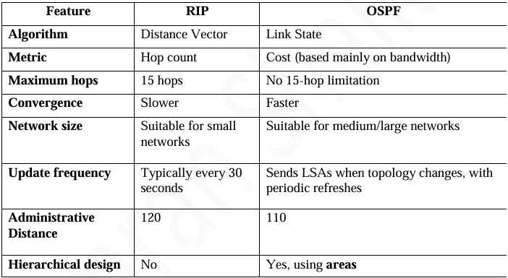

OSPF Effectiveness in Large Networks :- (Write any 2)

- Scalable: Handles large networks efficiently.
- Fast Convergence: Quickly adapts to network changes.
- Areas: Divides networks into smaller areas to reduce traffic.
- Shortest Path: Uses Dijkstra’s algorithm to find the best path.
- Less Overhead: Sends updates mainly when changes occur.
- Load Balancing: Supports multiple equal-cost paths.

20. Distinguish between dynamic routing and static routing on the Basis of
configuration, security, cost and routing protocols.
Ans.
Basis | Static Routing | Dynamic Routing
Configuration | Manually configured by the network administrator | Automatically updated by routing protocols
Security | More secure because routers are not shared automatically | Less secure as routing information is exchanged between routers
Cost | Low cost; requires less router resources | Higher cost due to CPU, memory and bandwidth usage
Routing Protocols | Does not use routing protocols | Uses protocols like OSPF, RIP, BGP

6 marks
21. Differentiate between
Distance vector routing and link state routing. ( any 6 points)
Ans.

Distance Vector Routing | Link State Routing
1. Shares routing information with neighbouring routers. | Shares link-state information with routers in the network/area.
2. Uses distance and direction to find routes. | Uses a complete network topology to find routes.
3. Uses algorithms such as Bellman-Ford. | Uses Dijkstra’s Shortest Path First algorithm.
4. Has slower convergence. | Has faster convergence.
5. Requires less CPU and memory. | Requires more CPU and memory.
6. Example: RIP. | Example: OSPF, IS-IS.

22.A network administrator wants to check whether a host with IPv4 address
192.168.1.20 is reachable from a host with IPv4 address 192.168.1.10. The administrator uses the ping command.

i. Which ICMP query message is generated by the source host? (1 Mark)
ii. Which ICMP query message is returned by the destination host? (1 Mark)
iii. Explain the purpose of the Identifier and Sequence Number fields in the ICMP message. (2 Marks)
iv. If the source receives an ICMP Echo Reply, what can the administrator conclude? What cannot be concluded? (2 Marks)
Ans.
i. ICMP Echo Request is sent by the source host

ii. ICMP Echo Reply is returned by the destination host.

iii. Purpose of Identifier and Sequence Number : -
- Identifier: Identifies the ping session/request so that the reply can be matched with the correct request.
- Sequence Number: Numbers each Echo Request and Reply, helping identify the order of messages and detect missing replies.

iv. Conclusion from ICMP Echo Reply : -
Can conclude :
- The destination host is reachable.
- IP connectivity between the two hosts is working.
- The destination responded to the ICMP Echo Request.
Cannot conclude :
- It does not guarantee that all network services or applications on the destination are working.
- It does not guarantee that the network is completely error-free or that every packet will reach the destination.

23. A router R1 has following route in its routing table.
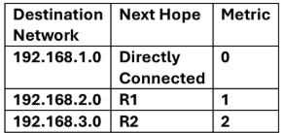
Design “RIP Response message” for R1 to send its neighbouring router R4.

Ans.
RIP Response Message
R1 sends its routing information to neighbouring router R4. In RIP, the metric is increased by 1 hop when the information is advertised.

RIP Response from R1 to R4
Destination Network | Metric
192.168.1.0 | 1
192.168.2.0 | 2
192.168.3.0 | 3

Explanation
- 192.168.1.0 → Directly connected to R1 → advertised as 1 hop
- 192.168.2.0 → Metric 1 at R1 → advertised as 2 hops
- 192.168.3.0 → Metric 2 at R1 → advertised as 3 hops

Therefore, R1's RIP Response to R4 contains the above three networks with metrics 1, 2, and 3.

